Document D: Palestinian Refugees
Palestinian Refugee Displacement from Ramle in 1948 (Source: Red Cross)

Palestinian Refugee Camp, 1949 (Source: Red Cross)
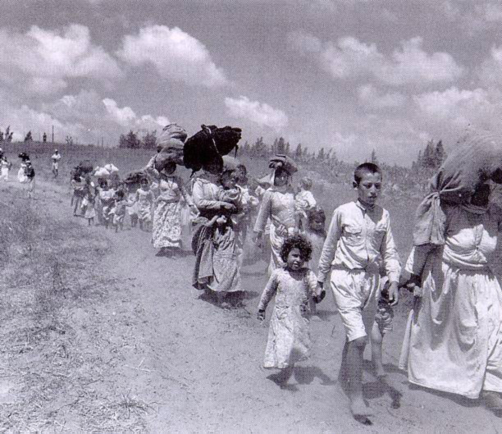

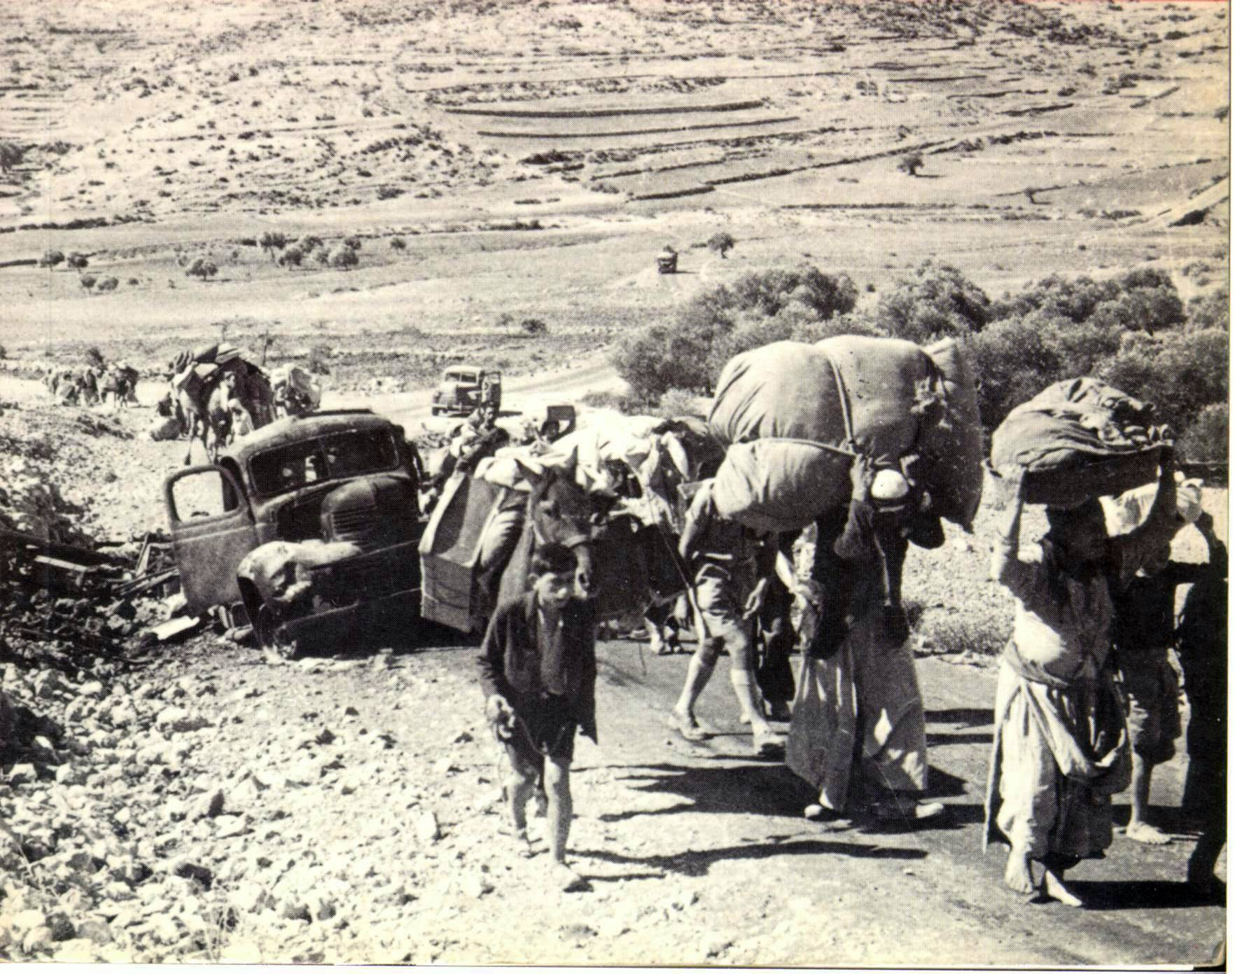

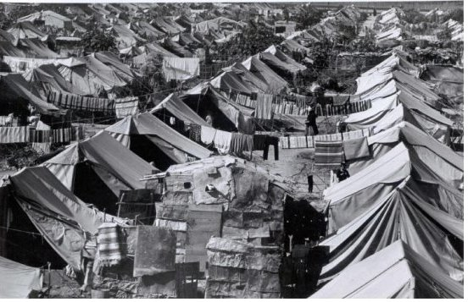
Refugee Camp

“Everyone thought that we were just going for a few days, and then we’d come back. We didn’t take anything with us, just a tiny bit. The people—where can they go? The land must be returned to its people. We have houses and land. Everything we have is there. It’s not only one or two who lost their land, it’s thousands. Our land is so big! A lot of land with oranges, and fruits, and guavas and trees…The sea is there! And the valley. The people who used to have land and harvest everything themselves, now they just sit at home, and are given a little bit of sugar and rice.” ~ Palestinian refugee

“I remember the homeland. And I still remember the Jews. I remember the Jews started to shoot bullets on the eastern side of one of the fields, towards a group of boys playing. Their parents started shouting and calling them. I remember. Then people fled—riding donkeys and camels. We went to Lid…then to Tire. Then to Jimzu…after that, to Funduq. Then we went to Deir Ghassana. From Deir Ghassana, to Deir Sharaf, From Deir Sharaf, to Balata village. We set up near Jacob’s Well. We started making shacks from burlap sacks.” ~Palestinian refugee

